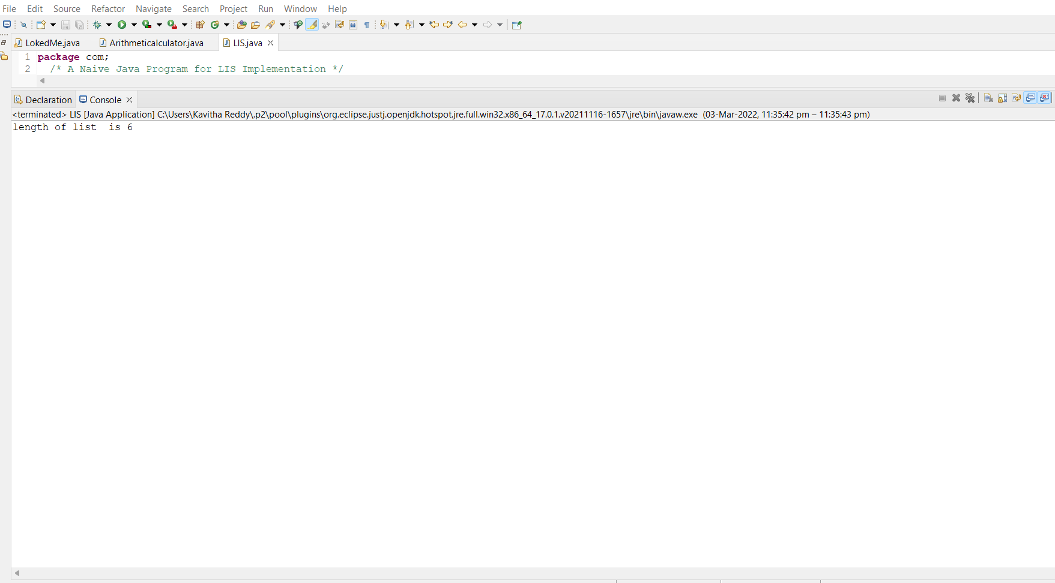

After running of the program we get output for Largest Increasing Subsequence